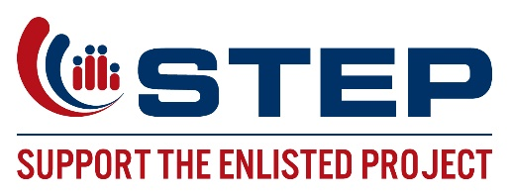
Job Title: Development Associate
Location: San Diego, CA
Reports to: Director of Development
______________________________________________________________________________

Who we are:

Support the Enlisted Project (STEP) is a non-profit 501(c)3 organization, with the mission of providing emergency financial and transition assistance to active duty and recently discharged enlisted military and their families. We are looking for a dynamic, out-going individual to help our Development Department raising the funds to support our military and veteran families from our office in San Diego, CA. Our ideal Development Associate would be highly results-driven and competitive yet personable and collaborative. You must have an aptitude for persuasion, enjoy the challenges of fundraising, and be a creative problem-solver.

STEP is headquartered in San Diego, CA with an office in Santa Ana, CA.

Primary Responsibilities
- Manage and maintain donor database
- Process all incoming donations
- Reconcile donations monthly
- Create and update reports for development department
- Assist in the grant writing process
- Support CEO and development department through administrative functions
- Occasional support in the Events and Outreach departments as needed

Required Qualifications
- Associates degree (A.A.) or equivalent from two-year college or technical school; or equivalent combination of education and experience
- Two years of administrative support
- Previous CRM database experience
- Experience with Microsoft Office
- Experience working in nonprofit fundraising preferred

Knowledge/Skills
- Ability to receive, manage, track, record, and employ large amounts of data rapidly
- Well-developed reading and writing skills
- Proficient in MS WORD, Excel, PowerPoint and data base management
- Excellent organization skills and ability to prioritize workload to promptly meet deadlines
- Demonstrated ability to pay close attention to detail to ensure absolute accuracy, with emphasis on neatness, professionalism, and appropriateness in all work performed
- Ability to think creatively and efficiently, to analyze and solve problems
- Strong written and oral communication skills
- Demonstrated interpersonal skills to establish and maintain respectful working relationships with an emphasis on tact, diplomacy, flexibility, teamwork, professionalism, and discretion
- Experience and/or knowledge of the military lifestyle preferred

Hours
Full time- Monday to Friday 8am-5pm
May include some weekends and evenings

To apply submit the following to jobs@stepsocal.org with subject line: Development Associate
- Cover Letter detailing experience as outlined above
- Resume
- Salary requirements

