Monthly Convening Activity: April 2018-Month of the Military Child Resource Mapping
- For this activity, first please list any organizations and their associated resources and programs that work with military connected youth in your group’s assigned region of San Diego.
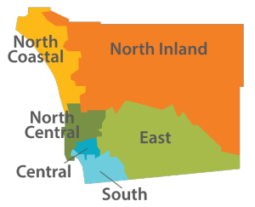
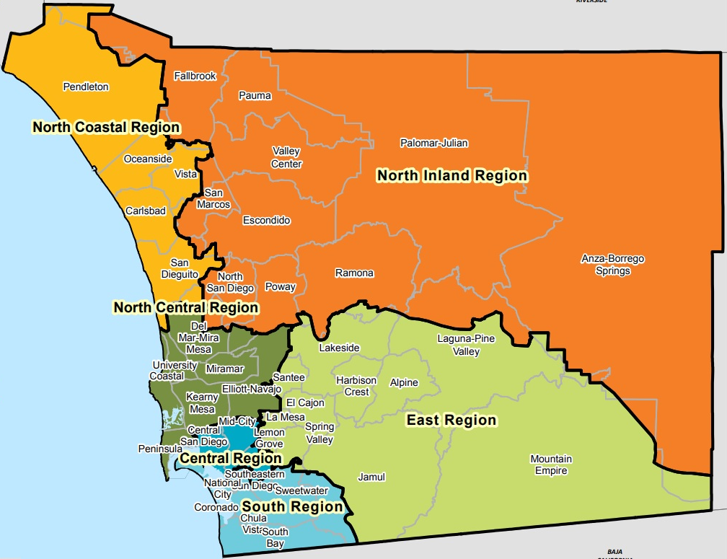

Live Well San Diego County Map (https://www.sandiegocounty.gov/content/sdc/live_well_san_diego.html).

(https://bluestarfam.org/survey/).

COUNTY REGIONS

1 - North Coastal
2 - North Inland
3 - North Central
4 - Central
5 - East
6 - South

HHSA Regions & Communities Map (https://www.sandiegocounty.gov/content/sdc/live_well_san_diego.html).

ACTION: Take butcher paper and please indicate youth serving organizations in the following format:
Organization Name | 1 Sentence Description | Any Point of Contacts
North Central
Big Brothers Big Sisters | Serving youth of military families with 1:1 role models | Ryan Landis, ryanl@sdbigs.org
Armed Services YMCA | Provide a wide array of programs for military families | 760-385-7921
Jewish Family Service
Produce for Patriots | Fighting to end food insecurity for active duty families | Rob Meadows: produceforpatriots@gmail.com  www.produceforpatriots.org
Helping Paws Foundation | Keep military families and vets united with their pets. 501©(3) covers veterinary costs troops can’t. | hannahmullins@helpingpawssandiego.org  602-791-0625
Lincoln Housing
Blue Star Families

Central
USO
Airport & Downtown | - Food Bank  - Dinners  - Teen Talks  - Activity/tickets to sport events  - MBYC Family Day
MCRD | Library  Youth Sports
Navy Federal | Financial Presentations
New Break Church | Church groups
Globe LJP and Cygnet Theatres
VFW
Holiday parties
SAY – SD
Operation BIGS
Murphy Canyon Youth Center
Friday Night Live
SD County Office Events
Leadership substance abuse programs
Armed Services YMCA
Outdoor Outreach
MilTeen Chat App
Balboa MAP – Military Appreciation Program
Red Cross – Babysitting safety classes
Travis Manion Foundation – youth mentorship
Boys + Girls Club

East
Santee/El Cajon/La Mesa/Alpine Teen Centers | Hang out/connection for teens
Libraries | Workshops; kid/teen programs
YMCA/Recreation Centers
Military coffee for families @ the schools
Skyline Church | Military family programs
4 H Programs
Mil Teen Chat App
Anchor for Life

South
NBSD
- EFMP
- Fleet and Family
- FOCUS
- MWR
- WIC
- Student Liaison office
Lincoln Housing
Veteran’s Connect @ the Chula Vista Library
The Rock Church @ San Ysidro
Armed Services YMCA
ASY Summer Camp @ Bayview
South Region Live Well Center (NC)
Kids Turn
New Hope Military Ministry (Chula Vista)

- As a table, please create at least 5 questions that you would military connected youth to answer. Be inquisitive of what you would like to learn from them.
- What keeps you up at night?
- What’s your favorite food?
- Do you have or want a pet?
- Do you need anything?
- Are you lonely?
- Do you play or want to play a sport?
- What’s the hardest part about being a military kid?
- What after school programs do you know about or utilize?
- What matters most to you?
- What is your favorite activity to do off base?
- What fun activity would you like to do in San Diego if money isn’t an issue?
- How do you cope with change?
- How do you cope with feelings?
- How do you cope with failures?
- What do you think we don’t understand?
- What makes you feel cared about?
- How do you want to connect with other military kids?
- What is the platform used most?
- What are your coping strategies?
- What do you do on tough days?

