|  |
| --- |
| Drawing of reindeer flying through a starry sky |
| |  |  |  |  |  |  |  |  | | --- | --- | --- | --- | --- | --- | --- | --- | | |  | | --- | | Ingredients for 10 servings | | ¼ cup cream cheese ¼ cup sour cream 1 oz club house ranch seasoning | | 12 oz frozen spinach, thawed and drained 11 oz thin crust pizza dough | | ½ cup pesto 2 tablespoons unsalted butter, melted 2 oz garlic, minced | | 1 tablespoon club house italian herbs ½ cup parmesan cheese | | marinara sauce, for dipping | |  | | | |  |  | | --- | --- | | [Christmas Tree Pull-Apart Bread] | Holidays 2020 (from Adrian Edquid) | | |
|  |

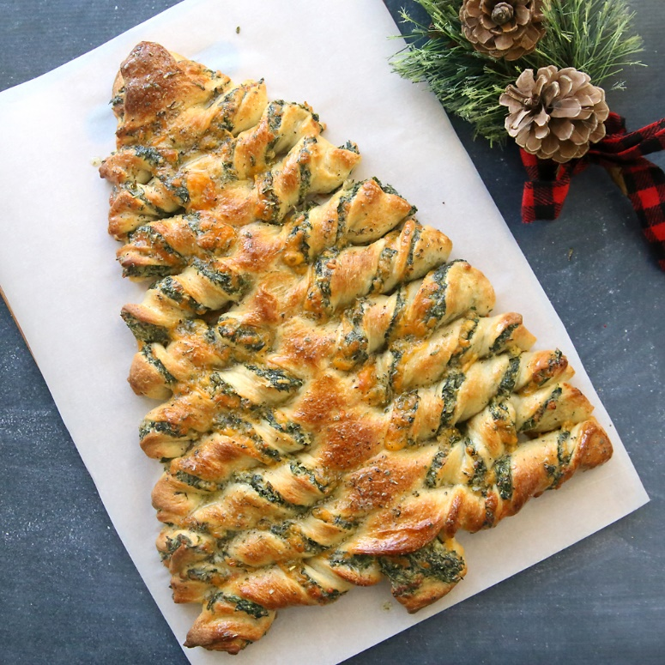

|  |  |  |  |  |  |  |  |
| --- | --- | --- | --- | --- | --- | --- | --- |
| |  |  |  |  |  |  |  | | --- | --- | --- | --- | --- | --- | --- | | |  | | --- | | Preheat the oven to 400°F (200°C). Flip a baking sheet upside down and place a piece of parchment | | paper on top. Set aside. | |  | | In a medium bowl, combine the cream cheese, sour cream, and Club House ranch dip seasoning. | | tir until well mixed. Fold in the spinach. Set aside. | |  | | |

|  |  |  |
| --- | --- | --- |
|  |  |  |
|  | |  | | --- | | Roll out the tube of pizza dough on a piece of parchment paper set on a flat. | | surface. Using a pizza cutter or knife, cut from a bottom corner to the center of | | the top. Repeat on the other side so you have 1 full triangle and 2 halves of a | | triangle on either side. | |  | | Transfer both side-triangle pieces to the prepared baking sheet. Pinch the | | middle seam to seal and stretch the dough to form a single triangle. | |  | | Spread the spinach dip over a side of the triangle. | |  | | Spread the pesto over the other side of the triangle. | |  | | Flip the remaining dough triangle on top of the filling and remove the | | parchment from the top. Stretch the dough to cover completely. | | Drawing of Christmas lights |
|  |  |  |
|  |  |  |
|  |  |  |
|  | |  | | --- | | Using a pizza cutter or knife, make horizontal slices about 1 inch apart from the | | top to bottom, leaving the middle “trunk” of the tree intact. | |  | | Pull the strips outwards and twist. | |  | | In a small bowl, mix the melted butter and garlic and brush over the tree. | |  | | Sprinkle with the Club House Italian herbs and shredded Parmesan cheese. | |  | | Bake the tree for 12-15 minutes, or until golden brown and the cheese has melted. | |  | | Serve with marinara sauce and enjoy! | |  | |  | | Drawing of gingerbread cookies |
|  |  |  |