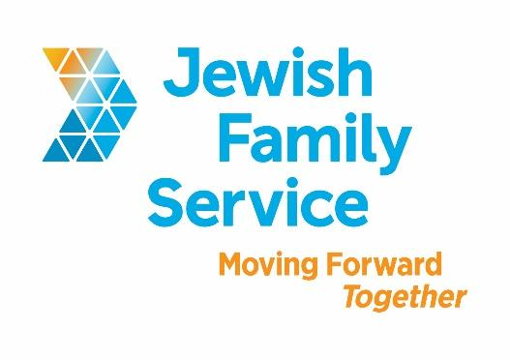

Position Title: Director of Positive Parenting

Organization: Jewish Family Service of San Diego

Position Type: Full-time; exempt

Standardized Benefits: Benefits for this position include a 401(k) plan, medical, dental and vision coverage, flexible spending accounts, life insurance and generous holiday benefits.

Position Overview:

This position requires specialized knowledge of adult, children, and family services and a passion for supporting parents/caregivers with young children. The Director should have an understanding of the issues surrounding parent education, and the myriad of current programs available to ensure the success for this branch of programming. These include, but are not limited to programs in child welfare, mental health, pregnancy, early childhood education, mentoring, alcohol, other drug services, and case management. The Director must remain up to date with current developments in family and child welfare, as well as the human service field. This is a dynamic position. We are looking for an engaged leader to direct a diverse and high performing team.

The Director of Positive Parenting will report up to the Senior Director of Family and Community
services. This position includes the supervision of multiple positions. Supervisory responsibilities will
include the following employees; Program Supervisor, Program Data Specialist, Administrative
Assistant, Child Activity Coordinator, and the CSF Coordinator.

Goals:
- Provide overall vision, leadership and coordination of the Positive Parenting Department (including the Positive Parenting Program and the Parent Education Partnership)
- Plan, implement, administer and manage parent education services in accordance with agency and funder policies and requirements
- Hire, supervise and retain qualified departmental staff
- Monitor budgets for entire department
- Develop community partnerships for resource leveraging critical to the success of parent education programs

You’ll Need:

Education/Certification/Professional License:
Minimum of a Master’s degree in the field of human services and a California-licensed or license eligible mental health background with two years of post-Master’s experience.

Knowledge/Skills/Abilities/Experience:
Additional desired experience includes:
- Experience working in or supervising a public/government funded mental health program, ideally one that serves young children or parents with young children
- Experience in community outreach and comfort with public speaking to large groups
- Demonstrated evidence of leadership capacity
- Knowledge non-profit accounting and fiscal management with a minimum budget of $50,000

We’d Like You to Have:
- Training in Triple P and experience in delivery of evidence based parenting curricula
- Advanced planning and organizing skills
- Clear capacity for expressing ideas and recommendations from client and staff, both written and verbal
- Vision and strategic orientation in planning for the growth and development of the department
- Ability to access professional and para-professional educational needs and recommended programs to meet these needs
- Ability to recognize one’s own biases and to understand and control them
- Sensitivity to cultural differences present in the agency’s service populations
- Considerable ability in establishing and maintaining constructive relationships within and outside the agency
- Ability to teach, lead and encourage staff members towards personal career growth
- A noticeable sensitivity to the problems of others and a commitment to search for the resolution
- Experience keeping confidential information about staff, clients, agency and the community
- Adherence to professional ethics
- Ability to organize time and activities to meet assigned situations and work demands

Contact Information
To apply, please e-mail your cover letter, salary requirements, and resume to resume4321@jfssd.org. Incomplete submissions will not be considered. Please, no phone calls. Please, principals only. Please, local candidates only (relocation is not provided).

About Jewish Family Service of San Diego
Jewish Family Service of San Diego is a client-centered, impact-driven organization working to build a stronger, more resilient community. For nearly 100 years, Jewish Family Service has been a trusted resource for the entire community, offering an array of services that are always life-changing, and often life-saving. At Jewish Family Service, we believe our employees are the backbone of our agency. Our goal is your success. Come work at JFS and be our partner in Moving Forward Together. To learn more about JFS, please visit www.jfssd.org.

