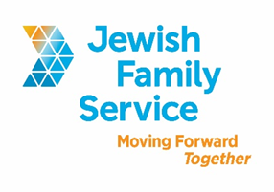

Position Title: Foodmobile Driver

Organization: Jewish Family Service of San Diego

Position Type: Part-time (average 6-12 hours per week, shifts starting between 10am and 2 pm), non-exempt.

Pay Rate: $13.09/hour

Position Overview
The Foodmobile program provides home-delivered kosher meals and friendly visits to older adults, and younger homebound disabled adults. The Foodmobile Driver is responsible for transporting and delivering these meals in a safe, courteous, and timely manner.

Position Requirements
The ideal candidate will have or be:
- Clean DMV record and reliable transportation
- High school diploma or GED
- Current CPR / First Aid certification a plus
- Able to read a map and abide by all traffic rules
- Ability to lift and move 25 pounds
- For liability insurance purposes, Foodmobile Drivers must be age 21 or older

Contact Information
To be considered, please email your cover letter (including salary requirement) and resume to resume4321@jfssd.org. Please, principals only. Please, no follow-up phone calls or emails.

About Jewish Family Service of San Diego
Jewish Family Service of San Diego is a client-centered, impact-driven organization working to build a stronger, more resilient community. For nearly 100 years, Jewish Family Service has been a trusted resource for the entire community, offering an array of services that are always life-changing, and often life-saving. At Jewish Family Service, we believe our employees are the backbone of our Agency. We strive to ensure that each employee is treated with dignity and respect. Our goal is your success. Come work at JFS and be our partner in Moving Forward Together. To learn more about JFS, please visit jfssd.org.

