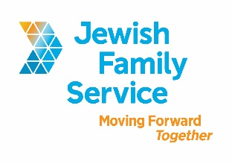

Position Title: Intake Specialist

Organization: Jewish Family Service of San Diego

Position Type: Full-time, non-exempt (37.50 hours per week)

Salary: $18-19/Hour

Standardized Benefits: Benefits for this position include a 401(k) plan, medical, dental and vision coverage, flexible spending accounts, life insurance and generous holiday benefits.

Position Overview
The Intake Specialist is responsible for receiving and responding to all incoming client inquiries and referrals in a timely manner and for coordinating services at Jewish Family Service of San Diego.

Essential Duties and Responsibilities: The Intake Specialist works as a member of the Intake Team, and provides the following:
- Responds to incoming calls at JFS for client services; may meet with walk-ins as needed.
- Conducts initial assessment to identify individual needs and risk issues.
- Screens potential clients’ immediate needs for appropriate internal and external referrals.
- Maintains documentation of all communication.
- Schedules appointments, as needed.
- Ensures compliance with HIPAA regulations.
- Follows up with clients and/or referrals, as appropriate.
Minimum Desired Education and Experience:
- Ability to offer professional and friendly service in a fast-paced environment
- Minimum of one year customer service experience
- Excellent communication skills required
- Knowledge of local social services/community resources
- Bachelor’s Degree in a human service field preferred
- Experience with crisis management helpful
- Proficiency in Microsoft Word, Excel and Outlook
- Experience with client data tracking software

Contact Information
To be considered, please email your resume, cover letter (including salary requirement) to resume4321@jfssd.org. Be sure to include the position title in the subject line. Please, principals only, and no follow-up phone calls or emails.

About Jewish Family Service of San Diego
Jewish Family Service of San Diego is a client-centered, impact-driven organization working to build a stronger, more resilient community. For nearly 100 years, Jewish Family Service has been a trusted resource for the entire community, offering an array of services that are always life-changing, and often life-saving. At Jewish Family Service, we believe our employees are the backbone of our agency. Our goal is your success. Come work at JFS and be our partner in Moving Forward Together. To learn more about JFS, please visit www.jfssd.org.

