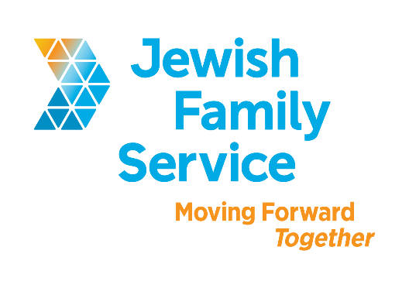

Position Title: Marketing Specialist & Copywriter

Organization: Jewish Family Service of San Diego

Position Type: Full-time (37.5 hours per week), non-exempt

Salary/Wage: $24.60 - $26.60/ hour

Standardized Benefits: Benefits for this position include a 401(k) plan; medical, dental, and vision coverage; flexible spending accounts; life insurance; and generous holiday benefits.

Position Overview

Do you like to help people? Do you want to use your creativity and contribute new ideas at work? We want to hear from you.

We’re looking for a stellar Marketing Specialist & Copywriter to take charge of our communication needs and cultivate relationships through print, social media, email, and web channels. Our community wants to know more about us—our services, our successes, and our incredible stories. If you know how to use your skills and talent to increase awareness and engagement. We sound like a perfect match.

Key Talents: You are proactive, passionate, and excited about working with new technology. You see the big picture and love to innovate. You are proud of your ability to write clear and compelling content that drives results and inspires actions. You are always learning and are excited to try new approaches to reach goals.

Specific duties include:
- Develop, write, and implement donor communications, including print newsletters, email newsletters, thank you letters, annual reports, and videos
- Develop, write, and implement client communications, including flyers, brochures, email blasts, and other print/online collateral
- Manage and develop social media campaigns to promote agency accomplishments, events, and fundraising goals—and meaningfully engage our diverse social media audiences
- Manage an agency-wide blog, including developing editorial calendar, writing articles, recruiting and managing guest bloggers and interns, and tracking goals
- Maintain the agency-wide Story Bank, including soliciting and editing stories, and co-leading storytelling workshops for staff
- Manage multiple projects and reprioritize when necessary
- Use your creativity to innovate with existing items and processes and develop new ones!

Position Requirements
The ideal candidate will have or be:
- Bachelor’s degree in marketing, English, or related field.

Minimum 5 years of experience in marketing, advertising, communications, or public relations. Experience in development/marketing in a nonprofit organization is a substantial plus.
- Excellent writing skills. Must be able to write with a voice! No dry reports here. Creativity is encouraged and welcomed.
- Proficiency in Photoshop, Office, and ability to learn other software as needed.
- Understanding of content management systems and email marketing software.
- Social media evangelist – ready to map a strategic course for our brand to maximize impact on these important communication channels.
- Strong understanding of brand management and its importance.
- Strong organizational and problem-solving skills.
- Exceptional interpersonal skills – you are a great listener and a great articulator of your vision.
- Ability to work diligently and efficiently, set priorities, and meet deadlines in a busy, fast-paced environment.
- Ability to work independently and as part of a team at our new Joan & Irwin Jacobs Campus – a great work environment!

Contact Information
To be considered, please email your cover letter (including salary requirement) and resume to resume4321@jfssd.org. Be sure to include the position title in the subject line. Please, principals only. Please, no follow-up phone calls or emails.

About Jewish Family Service of San Diego
Jewish Family Service of San Diego is a client-centered, impact-driven organization working to build a stronger, more resilient community. For nearly 100 years, Jewish Family Service has been a trusted resource for the entire community, offering an array of services that are always life-changing, and often life-saving. At Jewish Family Service, we believe our employees are the backbone of our Agency. We strive to ensure that each employee is treated with dignity and respect. Our goal is your success. Come work at JFS and be our partner in Moving Forward Together. To learn more about JFS, please visit jfssd.org.

