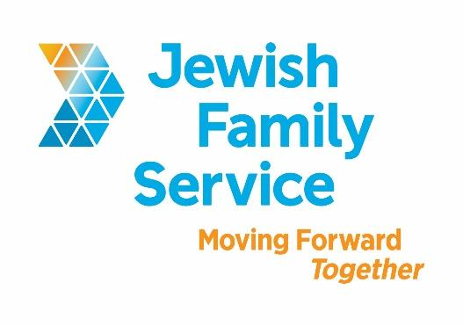

Position Title: Northern San Diego Rides & Smiles Coordinator

Organization: Jewish Family Service of San Diego

Position Type: Full-time (37.5 hours per week), non-exempt.
Salary: $17-20/Hour

Standardized Benefits: Benefits for this position include mileage reimbursement, healthcare, 401(k) plan and generous time off benefits.

Position Overview

On the Go provides a suite of transportation options for adults over the age of 60. Services include shuttles, excursions, fee based car service, taxi scrip and most importantly, the largest volunteer driving program (Rides & Smiles) in the San Diego Region for the last 11 years. Recently, On the Go celebrated its 250,000th ride.

Core hours are Monday through Friday from 8:30 am to 4:00pm with a brief evening check in. The schedule will require one weekend on-call every 4 to 5 weeks. Occasional weekend work will also be required.

The Northern San Diego Rides & Smiles Coordinator will coordinate transportation for approximately 575 individuals resulting in 700-1000 rides per month.

The Northern San Diego Rides & Smiles Coordinator will be responsible for:
- Coordinating daily dispatch of rides via use of specialized software, internet based transportation apps, telephone and program staff drivers.
- Managing the program within established parameters/goals as outlined in grant funding contracts.
- Monitoring quality of program via daily review of ride information for accuracy and analyzing both statistics and financial data on a monthly basis.
- Overseeing program to ensure operation within budget.
- Creating program reports on a monthly and as needed basis.
- Performing marketing and outreach via press releases, social media, special events and community presentations for transportation and other JFS programs in the Aging & Wellness Division.
- Managing volunteer driver performance and records on a daily and monthly basis.
- Performing consistent and meaningful acts of volunteer appreciation, via email, mail, phone, quarterly in-person training parties, and multiple annual specialized events.
- Ensuring quality customer service for participants and their families.
- Connecting participants, families, and community members with other Jewish Family Service programs and resources.
- Other tasks as assigned by supervisor.

Position Requirements
- Minimum of Associates Degree in Gerontology, Social Work, or relevant field, or 2 year’s experience coordinating transportation.
- A minimum two years’ experience working with seniors or vulnerable populations.
- A minimum one year of experience managing volunteers preferred.
- CPR Certificate preferred.
- Clean DMV and reliable transportation required.
- Able to pass required background check upon receiving job offer letter.
- Able to utilize maps and create routes via electronic maps, GPS and/or map book.
- Excellent reading, writing, and verbal communication skills with intermediate Microsoft Office proficiently (Word, Excel, Outlook, Power Point & Publisher).
- Excellent public speaking and presentation ability.
- Ability to intervene, persuade, mediate and negotiate with participants, families, vendors and community partners with poise and confidence.
- Knowledge of the normal and abnormal aging process, senior social services, Alzheimer’s disease, and dementia.
- Demonstrated experience in innovative community building and collaboration.
- Ability to access web-based work station while out of office.

Contact Information
To be considered, please review our website (particularly Aging & Wellness Services), then email your cover letter (including salary requirement) and resume to resume4321@jfssd.org. Please, principals only. Please, no follow-up phone calls or emails.

About Jewish Family Service of San Diego
Jewish Family Service of San Diego is a client-centered, impact-driven organization working to build a stronger, more resilient community. For nearly 100 years, Jewish Family Service has been a trusted resource for the entire community, offering an array of services that are always life-changing, and often life-saving. At Jewish Family Service, we believe our employees are the backbone of our agency. Our goal is your success. Come work at JFS and be our partner in Moving Forward Together. To learn more about JFS, please visit www.jfssd.org.

Key Words: Transportation Coordinator, Transportation Manager, Dispatch, Older Adult Services, Shuttles, Volunteer Driving Program, Logistics, Scheduler, Road Supervisor, Senior Services

