Background
For as long as the armed services have been calling men and women to serve their country there have been children raised in the military. A child of a military family is often subject to frequent moves as their parent or both parents are re-assigned and re-located. In some cases a child may be missing a parent for years at a time.
In 1986, Casper Weinberger, the Secretary of Defense at the time, acknowledged April as the Month of the Military Child in an attempt to show children of military families that their personal sacrifices are recognized with respect and gratitude. Despite the evident strain on the family unit, military children have truly unique community experience.₁

Did you know?
- Roughly around 2 million military children have experienced at least one parental deployment since 2001.
- Currently, there are 1.2 million military children of active duty members around the world.
- Almost 80 percent of military children go to public schools throughout the nation.
- The average military family are more likely to relocate often than civilian families.
- Deployments that are repeated and extended causes stressors in military children's lives.₂
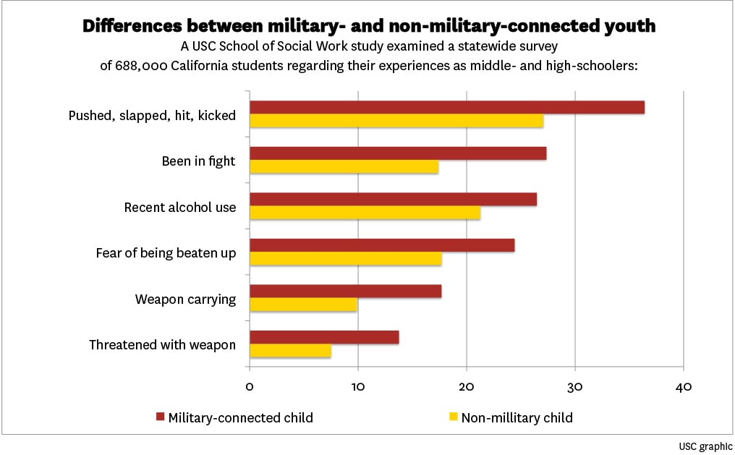
- Adverse Childhood Experiences are associated with physical health illnesses (such as heart disease, cancer, chronic lung disease) and mental health illnesses (such as alcoholism, drug addiction, depression).₃

Military vs. Civilian Children:₄
- Smoked 21.4% vs 16.5%
- Alcohol usage 45.2% vs 39.2%
- Marijuana usage 32.6% vs 27.5%
- Involved in a fight 27.4% vs 17.4%
- Victim of gossip/rumors 43.8% vs 36.9%
- Harassed sexually 43.4% vs 37.8%
- Fear of being hit 24.4% vs 17.7%
- Teased for looks 41.5% vs 35.4%

Picture retrieved from the University of Southern California Website₅
Unique Characteristics/Strengths of the Military Child
- Military children have the capacity for adaptation and resilience.
- Military kids often learn how to speak different languages.
- Military children are exposed to different cultures and places worldwide.
- Military children have unique experiences that only other military children can identify with.
- Military children have a great sense of honor, duty, sacrifice.

