DID YOU KNOW
- An estimated 8 percent (113,600 people) of San Diegans are living with serious mental illness. (https://www.sdfoundation.org/news-events/sdf-news/san-diego-mental-healthlandscape/)
- According to the VA San Diego Healthcare System nearly 25,000 Veterans have received care for PTSD in San Diego from 2010 - 2016 and 14.5% of all Veterans are diagnosed with some form of PTSD. (https://www.sandiego.va.gov/services/Post_Traumatic_Stress_Disorder.asp)
- About 20% of the U.S. population has at least one depressive symptom in a given month, and about 1 in 17 have a serious mental illness. (https://www.sdfoundation.org/news-events/sdf-news/san-diego-mental-health-landscape/)
- About 50% of people with severe mental illness are affected by substance abuse. 37% of alcohol abusers and 53% of drug abusers have mental illness. Of all people diagnosed as mentally ill, 29% abuse substances such as drugs or alcohol. (https://www.helpguide.org/articles/addictions/substance-abuse-and-mental-health.htm/)

MENTAL HEALTH CONCERNS
- Posttraumatic Stress Disorder (PTSD): Traumatic events, such as military combat can have life-long negative effects on humans such as trouble sleeping and substance abuse. “The 2014 JAMA Psychiatry study found the rate of PTSD to be 15 times higher in service members than civilians.” (https://www.nami.org/find-support/veterans-and-active-duty)
- Traumatic Brain Injury (TBI): A traumatic brain injury happens as the result of significant blow, or jolt to the head, causing a head injury. Negative effects that can take place as a result are headaches, memory problems and mood swings. (https://www.nami.org/find-support/veterans-and-active-duty)
- Depression: Feeling very low and unenergetic to do any normal daily activities. Feeling bad about yourself and wanting to just be lonely, and even thinking of harming yourself. “2014 JAMA Psychiatry study found the rate of depression to be five times higher in service members than civilians.”
(https://www.nami.org/find-support/veterans-and-active-duty)

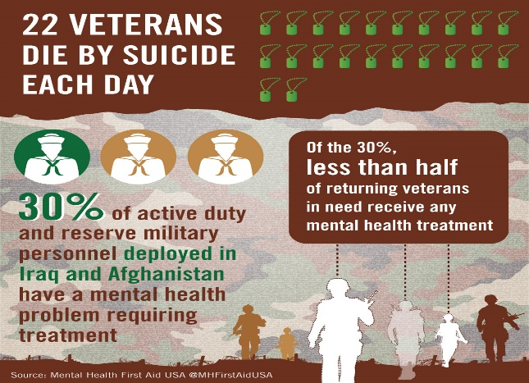
AVAILABLE RESOURCES IN SAN DIEGO
- San Diego Access and Crisis Line: (888-724-7240)
- 2-1-1 San Diego (https://211sandiego.org/)
- NAMI San Diego (https://namisandiego.org/)
- San Diego Network of Care for Behavioral Health
(http://sandiego.networkofcare.org/mh/)
- San Diego County HHSA-Behavioral Health Services
(https://www.sandiegocounty.gov/hhsa/programs/bhs/)
- Mental Health America (MHA) San Diego
(http://mhasd.org/)
- National Suicide Prevention Lifeline: (1-800-273-8255)
- Stepping Stone of SD, Inc. (https://steppingstonesd.org/)
- VA San Diego Health Care System
(https://www.sandiego.va.gov/)

https://pimsyehr.com/resources/mental-health

