Did You Know
- According to a 2015 study conducted by the U.S. DoD, 6.2% of married active duty members are in a dual-military marriage, meaning both spouses are members of the military ₍₁₎
- About 8 percent of all military members are single parents. ₍₁₎
- Military members began their families at an average age of 25 years old, whereas civilians begin theirs at an average age of 28. ₍₂₎
- According to the American Community Survey conducted in 2010, less than 2% of couples in the military are same sex couples. ₍₂₎
- Military families relocate 10 times more often than civilian families, on average every 2-3 years ₍₃₎
- Active Duty spouses who become pregnant receive 12 weeks of maternal leave.
- Active Duty spouses are non-deployable for 6 months after giving birth.
- In San Diego County, E-1 to E-4 service members with dependents are given $2,535 for their Basic Housing Allowance. ₍₄₎
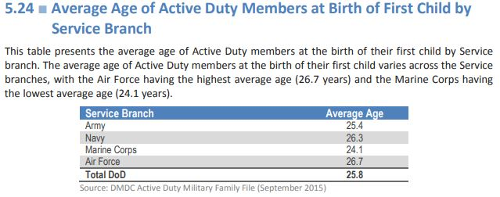₍₁₎
Things to Consider
- Military OneSource offers peer to peer support and specialized consultations for military families who are considering adoption
- The Department of Defense has an adoption reimbursement program for qualified military families. These reimbursements can cover medical expenses and other adoption fees, however they do not cover travel expenses ₍₅₎
- 2019 BAH for California service members https://militarybenefits.info/bah-rates-state/california/
Available Resources for Military Families
1. San Diego Military Outreach Ministries (SDMOM) http://www.sandiegomom.org
2. SAY San Diego Dads Corps https://www.saysandiego.org/program/healthy-start-military-familyesource-center/dads-corps/
3. SAY San Diego First 5, First Steps https://www.saysandiego.org/program/first-5-first-steps/
4. Operation Doula (San Diego, CA) https://www.militarybirthresourcenetwork.org/operation-doula
4. Military Birth Resource Network https://www.militarybirthresourcenetwork.org/san-diego#san-diegobalboa-chapter
5. MiltaryOneSource.com

